6/11/2020

Arran Logan-Riley

ID:2018000586

AOOP

Assesment-3

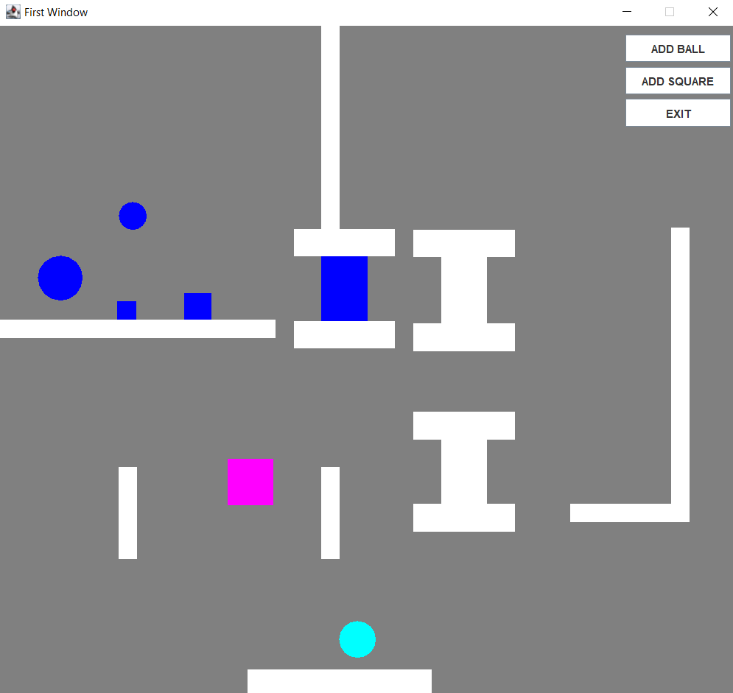

Figure

# Changed layout

During the design phase, I changed the layout of my app. The changes were made as It was not possible to implement gravity into my game. This meant that I had to move the trapdoor so the objects would naturally move onto to trap door. This change was also done to the disposal areas and conveyor that lead up to the final scanner. A layout change was made to make it so the conveyor on the far right was implemented. This was added as gravity was not implemented and the objects needed a way to get to the next part of the factory.

The objects no longer bounce of a triangle that was in the mock-up.

# Rule changes

I changed the way the crusher crushes items. Instead of turning the shape red it now changes it to magenta. This was done as I did not like the red colour. I did not end up adding the rules that the square is heavy, and the ball is light. This was not done adding this would have taken extra time.

I decided to get rid of the pipes in my program as my application would require gravity for pipes to work.

# Changed functionality

Instead of the scanner telling the crusher to crush the next item I made it so that the object that goes through the scanner has a property that is set to true or false when it goes through the scanner. This property is checked when the item goes through the crusher. I made it so when an object moves through a scanner or a crusher the middle of that object will turn into the colour of the last object that just went through it.

# Class diagram changes

The changes to the class diagram were significant. Not a lot that was specified in the class diagram stayed the same. This was expected as I did not understand how my code would work at the time.

The significant changes included using a class to store all the objects lists that are on the panel. Another major difference is that The properties and methods in the collision manager are completely different. In my class diagram, I did not understand boundaries and how they would work, so they were not shown in the class diagram.

Changes were made to the shape abstract class, although I should have added this class in, my program was too far through development to add this class. I should have added this class earlier. There is something similar to the abstract shape class that was implemented into my code, this is the moving object abstract class which has the methods and properties of a moving object. There is also a polygon class that was created, anything that is a static shape extended this class and used its properties to draw its shape.

The first window was implemented as in my class diagram, although there were some extra bits in Firstwindow that I added.

A notable surprise was that my paintShpae method was implemented into the program, although it was used in many classes which I had not shown in my class diagram.

Overall there were a lot of changes made between creating my class diagram and programming my factory.

# What could have been done differently to improve my app

There are a couple of things I would have liked to have done differently. The first one being that I would have liked to use interfaces, abstract classes and packages to their full extent as I was not able to do this because of time constraints. I have run into an issue where when I delete objects in my disposal area object a “Something interrupted me while sleeping...” error is called. If I had more time to work on my app I would fix this bug.

I would have liked to implement gravity, although I knew this would take a long time to implement so I chose against it. This led to some compromises in the UI as I had intended to implement gravity as shown in my planning document it worked out in the end as gravity was not a major requirement.

# Reflection

I would like to say that this semester has not been an easy one, due to current global events regarding the COVID-19. Although I did put my best into my work it has not exactly been smooth, and it has affected my learning ability.

During this paper, I have learnt many very useful things about programming, and it will be useful for me in the future as I want to pursue a career in this field.

I believe the course was held to its best it could be during these events and the lecturer did a very good job. The course material could be updated to modern standards, but this is only a minor issue as I understand the programming industry moves incredibly fast and this is hard to do.

I found coding labs in class and even when things were moved online to be very helpful as its much easier to learn to code by actually coding. Let's hope next year is better.